OFFICIAL COORDINATION REQUEST FOR
NON-ROUTINE OPERATIONS AND MAINTENANCE

COORDINATION TITLE- 22BON007 U14 and U15 B2FGE Hydraulic Testing
COORDINATION DATE- 25 March, 2022
PROJECT- Bonneville Dam
RESPONSE DATE- 11 April 2022

Description of the problem
The B2FGE program has installed a gatewell flow control device for the A and B gatewells of Unit 15. Concrete corbels are located downstream of the vertical barrier screens (VBS) at elevation +31 feet. Hydraulic testing is needed to determine if any structural modifications are required before continuing with installation in the rest of the Second Powerhouse (PH2) units. The hydraulic testing goals are to collect data to better understand the hydraulic conditions for juvenile fish passage through the gatewells during turbine operations in the upper 1% peak efficiency range. Unit 14 and 15 pressure testing will provide data that show the magnitude of the transient pressure waves acting on the corbels during the turbine shutdown and startup procedures and will show turbulent pressure fluctuations during normal operations in the 1% peak efficiency turbine operation range. Hydraulic testing is scheduled from late May to early June timeframe when we have the most certainty of achieving the testing flows in the upper 1% peak turbine efficiency. Results from testing of hydraulic conditions will be coordinated through FFDRWG and reported to FPOM.

Test objectives include:
    - Hydraulic measurements in all three gatewells of Unit 15: 15A, 15B, 15C.
    - Two flow treatments per gatewell: 14.3–14.8 kcfs (mid-1%) and 18.0–18.5 kcfs (upper 1%).
    - One day for testing each treatment per gatewell, totaling six working days. Testing will be conducted during daylight hours, 0600–1800.
    - Pressure transducers will be installed in the 14A and 15A head gate slot near the concrete corbel downstream of VBS. Testing will be conducted during daylight hours, 0600–1800.

Table 1 shows the Unit 14 and 15 outage and testing schedule sequence. Days are calculated Mon-Thurs. Memorial Day Federal Holiday falls on Monday May 30, 2022. There are a few opportunities to have tasks performed on Fridays if project staffing are available. Pressure sensor equipment will be abandoned in place after data collection. This is located downstream of the VBS in “fish free” water and will be retrieved by ODB staff at subsequent unit outages currently scheduled in July and August. Only one unit at a time can be dewatered, equipment installed, watered up, and pressure tested.

Table 1: Unit Outage Sequence and Schedule
Unit 14 Baseline Testing | Start Date | End Date | Duration (days)
Dewater Unit | Monday 5/16/2022 | Tuesday 5/17/2022 | 2
Pressure sensor installation | Wednesday 5/18/2022 | Wednesday 5/18/2022 | 1
Rewater Unit | Thursday 5/19/2022 | Thursday 5/19/2022 | 1
Pressure Testing | Friday 5/20/2022 | Friday 5/20/2022 | 1
Unit 15 Modified Unit Testing
Dewater Unit | Monday 5/23/2022 | Tuesday 5/24/2022 | 2
Pressure Sensor Installation | Wednesday 5/25/2022 | Wednesday 5/25/2022 | 1
Rewater Unit | Thursday 5/26/2022 | Thursday 5/26/2022 | 1
Wet Run / Equipment Shakedown | Tuesday 5/31/2022 | Tuesday 5/31/2022 | 1
Pressure/ Velocity Testing (Daily VBS Cleaning Required) | Wednesday 6/1/2022 | Thursday 6/9/2022 | 6

Both units adjacent to the test unit will be operated at mid-1% peak efficiency during testing to provide stable operations to minimize hydraulic changes in the gatewell. All unit operations will be within the existing 1% peak efficiency range (see FPP Table BON-15), with unit availability contingent on total river flow, spill, and unit priority. A daily schedule will be provided to Bonneville Dam Operations. VBSs will be inspected and cleaned as needed prior to testing.

Type of outage required
This coordination covers:
- PH2 unit 14 and 15 operations outside the FPP established turbine range for fish protection (2022 FPP BON 4.2).
- Change to PH2 unit priority during hydraulic testing (2022 FPP BON 4.1.1, Table BON-13).
- Hydraulic measurement equipment in the operating gatewells of modified unit 15 (2022 FPP, Appendix A, 2.2.1). Please see Figures 1 – 3 of the gatewell hydraulic testing equipment.

Impact on facility operation
Acoustic Doppler Velocimeters (ADV) (Fig.1) and traversing beam (Fig. 2) will be used to collect mid 1% and upper 1% gatewell hydraulic data in the A, B, and C slot of Unit 15, one gatewell at a time, for a total of six test days. Equipment will be set up around each gatewell (Fig. 3) and all testing will occur during daylight hours only, 0600-1800.

Units 14 and 15 pressure testing data collection will include unit starts and stops and operations in the mid and upper 1% peak efficiency range.

Units 14 and 15 test operations in upper 1% range for pressure and gatewell hydraulic testing may be out of FPP criteria (see FPP BON section 4.2).

Figure 1: Nortek Vectrino ADV

Figure 2: Traversing Beam Inside of Gatewell

Figure 3: Probe Orientation within Gatewell (Looking East)

Impact on unit priority
Unit outages and test operations may result in PH2 units being operated out of FPP priority order (see FPP BON Table BON-13). Gatewell hydraulic testing in Unit 15 is optimized with symmetrical flow through operations of adjacent units. If conditions allow, operate adjacent units 14 and 16 in the mid-1% during Unit 15 testing. Unit 14 and 15 pressure testing should also include operations of adjacent units.

FPP PH2 Unit Priority - 11, 18, 12, 17, 13, 14, 15, 16
PH2 Unit 15 testing priority - 11, 18, 15, 14, 16, 12, 17, 13
PH2 Unit 14 testing priority – 11, 18, 14, 13, 15, 12, 17, 13

Impact on forebay/tailwater operation
No impacts to forebay or tailwater operation are anticipated as total river flow at this time of year should be sufficient for upper 1% peak efficiency testing. 57 feet of head or less is needed to be able to pass >18 kcfs through the unit with STS installed. A 74-75 ft forebay operation would require approximately 210 kcfs river flow to achieve that head.

Impact on spill
Unit outages for pressure sensor installation may reduce PH2 capacity and increase spill.

Analysis of potential impacts to fish

Please see Table BON-2 which displays the Bonneville Dam juvenile salmonid passage timing for the most recent 10 years based on daily and yearly collection data. 2012 through 2021 10%, 50%, 90% passage dates for each year are included as well as the 10-year median, min, and max. Table 2 below is the average 90% passage date at BON for yearling Chinook, steelhead, coho, sockeye, and sub yearling Chinook as reported in DART 2022.

Table 2: 2012-2021 average 90% passage dates
Sp. | 90% passage date
Ch1 | 5/20
ST | 5/24
Co | 5/28
So | 5/27
Ch0 | 7/15
Source: DART 2022

Sub yearling chinook smolt index passage data for each year 2012-2021 in Figure 4 includes a peak in April to early May and another peak in July. Figure 4 is included here to better illustrate the passage timing for sub yearling Chinook. Figure 5 includes BON smolt index juvenile lamprey passage data for each year 2012-2018.

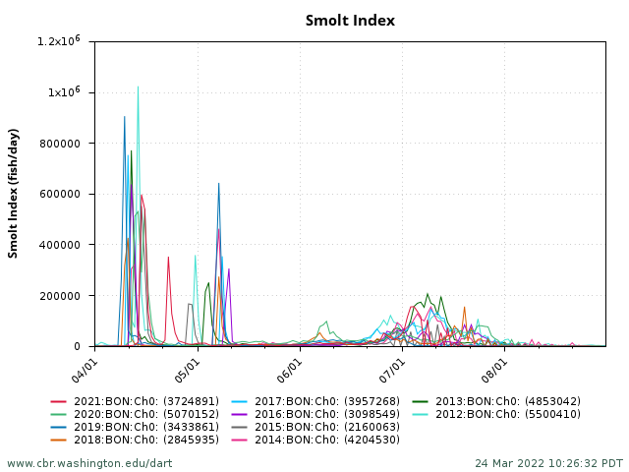
DART Data Citation - Columbia River DART, Columbia Basin Research, University of Washington. (2022). Smolt Index Graphics & Text. Available from http://www.cbr.washington.edu/dart/query/smolt_graph_text
Figure 4: Sub yearling Chinook BON passage timing for each year 2012-2021

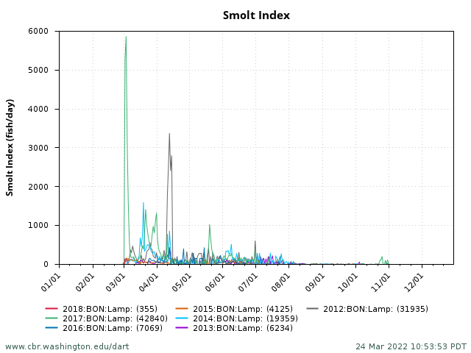
DART Data Citation - Columbia River DART, Columbia Basin Research, University of Washington. (2022). Smolt Index Graphics & Text. Available from http://www.cbr.washington.edu/dart/query/smolt_graph_text
Figure 5: Juvenile lamprey BON passage timing for each year 2012-2018

Summary statement - expected impacts on:

Downstream Juvenile Migrants:
Data collection will occur close to the 90% passage dates for yearling Chinook, steelhead, coho, sockeye and between peaks for sub yearling Chinook. Small numbers of juvenile lamprey will be migrating during the data collection period.

The data collection will likely have minor condition and mortality impacts to migrating run of the river juvenile salmonids and lamprey passing through the gatewells during unmodified Unit 14 upper 1% operations. Unit 15 has been modified so no impacts are expected as a result of operating in the upper 1%. The Unit 15 gatewell data collection equipment and traversing beam will be installed in a gatewell (one at a time) during mid and upper 1% operation and removed from the water at the end of each test day. Minor condition and mortality impacts may occur as a result of potential contact with the equipment.

Adult Fallback:
Adult Fallback through the Test Unit – Adult fallback is not expected to increase due to the testing operation. Adult fish passing through the Unit 15 test gatewell would be exposed to the Traversing Beam.

Upstream Migrants:
Unit priority will be modified, however, both Unit18 and 11 will remain first priority units. No impacts to upstream migrants are expected.

Comments from agencies
BPA –
-----Original Message-----
From: Bettin,Scott W (BPA) - EWP-4 <swbettin@bpa.gov>
Sent: Wednesday, March 30, 2022 8:04 AM
To: Rerecich, Jonathan G CIV USARMY CENWP (USA) <Jonathan.G.Rerecich@usace.army.mil>; Mackey, Tammy M CIV USARMY CENWP (USA) <Tammy.M.Mackey@usace.army.mil>; Wilson-Fey, Max P CIV USARMY CENWP (USA) <Max.P.Wilson-Fey@usace.army.mil>; Derugin, Andrew G CIV (USA) <Andrew.G.Derugin@usace.army.mil>
Cc: Hausmann,Benjamin J (BPA) - EWL-4 <bjhausmann@bpa.gov>
Subject: [Non-DoD Source] RE: DRAFT - 22BONXX B2FGE Unit 14 and 15 Hydraulic Testing

It looks like unit 13 will not be returning to service on 3/31/2022. The new return date is 9/1/2022. Will that substantially impact the study of unit 14 as the request is to run the adjoining units? -s

-----Original Message-----
From: Hausmann,Benjamin J (BPA) - EWL-4 <bjhausmann@bpa.gov>
Sent: Monday, March 28, 2022 2:47 PM
Subject: [Non-DoD Source] RE: FPOM: Official Coordination -22BON007 MOC U14 and U15 B2FGE Hydraulic Testing

Thanks Tammy. Looking forward to these test results and hoping this is the path forward for this long-standing issue.

Ben

WDFW- -----Original Message-----
From: Morrill, Charles (DFW) <Charles.Morrill@dfw.wa.gov>
Sent: Monday, March 28, 2022 1:58 PM
Subject: [Non-DoD Source] RE: FPOM: Official Coordination -22BON007 MOC U14 and U15 B2FGE Hydraulic Testing

Ahh... Thank you Tammy ;-)

Charlie

-----Original Message-----
From: Mackey, Tammy M CIV USARMY CENWP (USA) <Tammy.M.Mackey@usace.army.mil>
Sent: Monday, March 28, 2022 1:38 PM
Subject: RE: FPOM: Official Coordination -22BON007 MOC U14 and U15 B2FGE Hydraulic Testing
External Email

Thanks Charlie.

The date for comments is two weeks from today, which is the standard comment period. It happens to fall within the same week as FPOM but there is no need to hold MOCs until an FPOM for comments. We will always accept additional comments at FPOM if provided... however, the official comment period for the PDT to make decisions and move forward ends on 11 April.
Tam
-----Original Message-----
From: Morrill, Charles (DFW) <Charles.Morrill@dfw.wa.gov>
Sent: Monday, March 28, 2022 1:28 PM
Subject: [Non-DoD Source] RE: FPOM: Official Coordination -22BON007 MOC U14 and U15 B2FGE Hydraulic Testing

Hi Tammy,

Given our prior discussions and reviewing the MOC, I am not uncomfortable with the hydraulic testing as described in the MOC.

I do however wonder why the closing date in one day prior to our April FPOM. If there are significant concerns expressed, I will consider those prior to a final recommendation.

Thanks Tammy

;-)
Charlie

From: Mackey, Tammy M CIV USARMY CENWP (USA) <Tammy.M.Mackey@usace.army.mil>
Sent: Monday, March 28, 2022 9:18 AM
Subject: FPOM: Official Coordination -22BON007 MOC U14 and U15 B2FGE Hydraulic Testing

Please see the attached MOC. Comments are requested by 11 April 2022.
Thank you,
Tammy

Final coordination results

Please email or call with questions or concerns.
Thank you,

Tammy Mackey
NWP Operations Division Fishery Section Chief
Acting Columbia River Coordinator
503-961-5733
Tammy.m.mackey@usace.army.mil

Jon Rerecich
Fish Passage Team
Environmental Resources Branch
USACE Portland District
503-808-4779
Jonathan.g.rerecich@usace.army.mil

